**Document 03 – Time Log Instructions**

You will record all time that you spend for this project (including thinking, meetings, *etc*) using the Time Log spreadsheet that will be shared with you on Google Drive. Your team will share the spreadsheet. The spreadsheet has three tabs.

***Individual Hours* Tab**

The **third** tab is “Individual Hours” as shown below. The first time you use the spreadsheet, you should type in your initials and name (the first person should replace my entry). Your total hours will be automatically calculated. Do not alter that field.

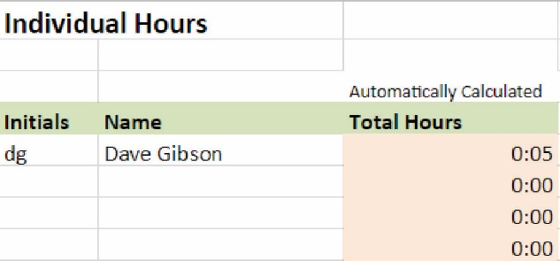

***Activity Codes* Tab**

The second tab is “Activity Codes” as shown below. You will use one of these codes to allocate each increment of time that you contribute to the project.

|  |  |
| --- | --- |
| **Activity Codes** |  |
|  |  |
|  | You will record all time (including thinking, meetings, etc) that you spend for this project using the Time Log tab on this spreadsheet. Use the Activity Codes below to indicate how your time was spent. |
|  |  |
| **Code** | **Task** |
| D | Any activity related to the analysis or design |
| C | Any activity related to coding |
| T | Any activity related to testing |
| P | Any activity related to presentations |
| O | Any other activity |

***Time Log* Tab**

The first tab is “Time Log” as shown below. Each time you work on the project you will make an entry by typing your initials, begin date and time, end date and time, interrupt time, activity code, and brief description of what you did. The total time and running total time will be automatically calculated. Do not alter those fields.

The date/time field is formatted; however, you don’t have to enter these exactly as shown. For example, for the first entry shown below, typing: “6/6 9 am” will produce the result shown.

Interrupt time is time you were not working. For example, you may have worked from 11 am to 1 pm, and taken 20 minutes for a snack. Thus, for interrupt time you would enter: “0:20”. For this to work properly, you must enter “h:mm”.

|  |  |  |  |  |  |  |  |
| --- | --- | --- | --- | --- | --- | --- | --- |
| **Time Log** |  |  |  |  |  |  |  |
|  |  |  |  |  |  |  |  |
|  |  |  |  | Automatically Calculated |  |  |  |
| **Initials** | **Beg Date/Time** | **End Date/Time** | **Int.Time** | **Tot Time** | **Run Total** | **Act Code** | **Description of Activity** |
|  | 06/05 09:00 AM | 06/05 09:00 AM | 0:00 | 0:00 | 0:00 | D |  |
| dg | 06/05 09:00 AM | 06/05 09:06 AM | 0:01 | 0:05 | 0:05 | D | Project overview in class |
|  |  |  |  |  |  |  |  |